Kuwait Autism Society
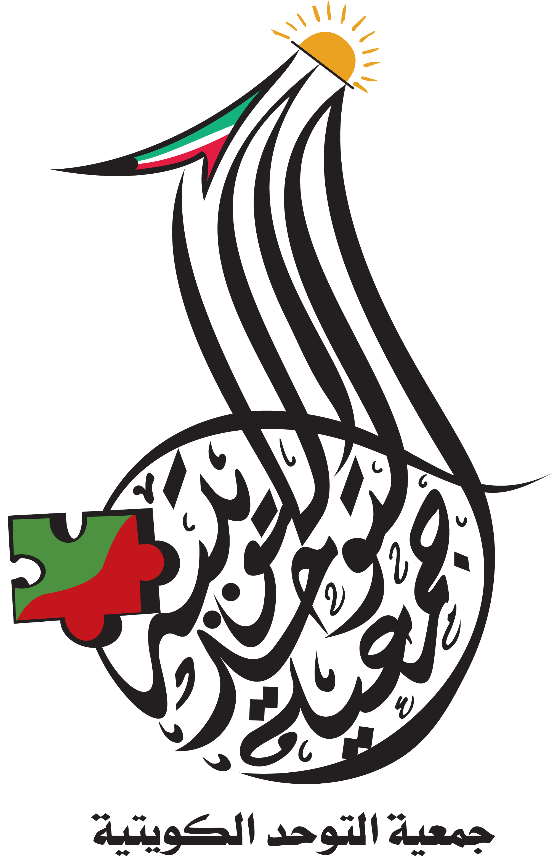
Registered Office: Kuwait – West Mishref –
Mubarak Al-Abdalla Area – Area 6 – Str. 3
Tel: +965 25309399
Fax: +965 25375091
Email: ksautism@gmail.com
Website: www.autism.org.kw

About KAS:

Kuwait Autism Society (KAS), a non-government organization (NGO) was established in 2006. It aims to support voluntary work, especially in the field of Autism. The society has also other goals which focuses on encouraging more research and studies in the field of Autism, organizing scientific conferences, in addition to training teachers, specialists in this field and parents and developing the existing programs.
The idea of creating Kuwait Autism Society was inspired by a group of parents and those interested in the education of children with autism. The aim was to support the efforts of Kuwait Center for Autism (KCA) which was founded in 1994. Kuwait Autism Society is seeking to develop services for people with autism and coordinating efforts with other institutions working in this field. The society focuses on supporting all the governmental and other efforts in the field of Autism and also cooperating with the authorized organizations to support assessment programs and early diagnosis for these children giving more opportunity for early intervention with them and programs they need at different stages of life. KAS services include issuing a specialized scientific journal contributes in spreading awareness of autism, publishing several books and translations on autism and communication issues and creating programs and special activities that provides people with autism with the latest international best practice, Cooperating with the GCC societies and international bodies.

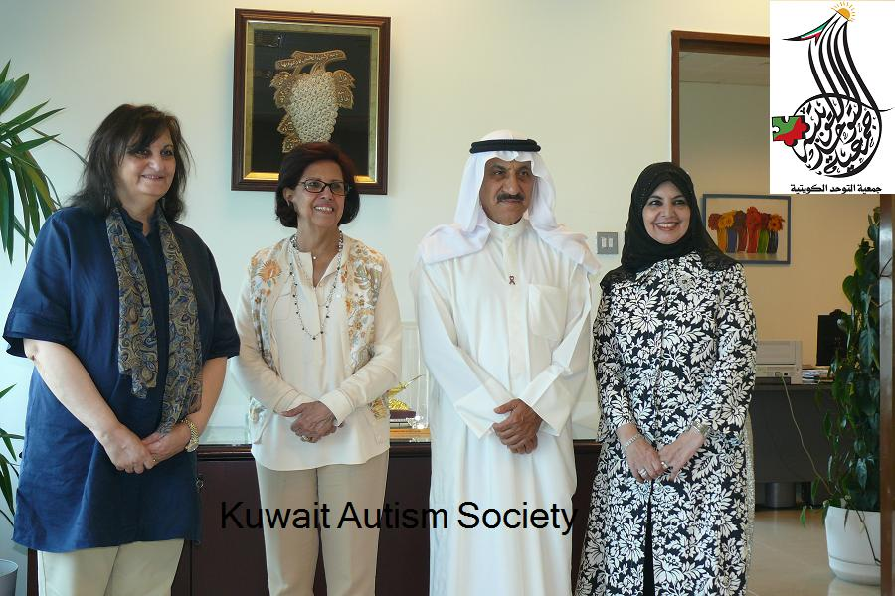
(Dr. Samira Al-Saad president of KAS with Dr. Abd-Elrida Ali dean of faculty of social sciences in Kuwait university when signing understanding agreement between Kuwait Autism Society and Social Sciences Faculty - 2012).
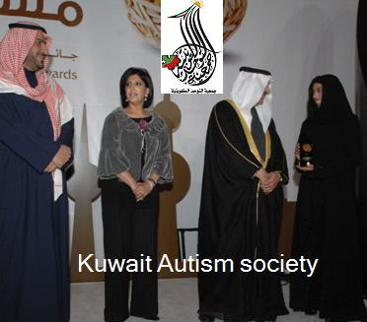
(Winning the Social Responsibility Prize delivered by the president of the Kuwaiti Council - 2008)
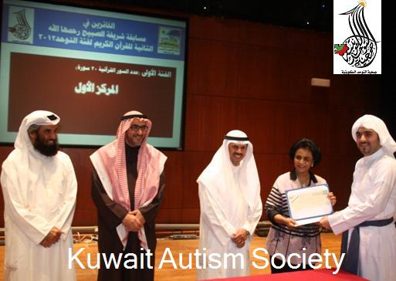
(Sheikha Fariha Al-Sabah Honoring a participant in Sharifa Al-Sobaih Qur’an yearly competition organized by Kuwait Autism Society – 2013)

